The First Sunday in Lent

February 26, 2023
8:45 & 11:00am

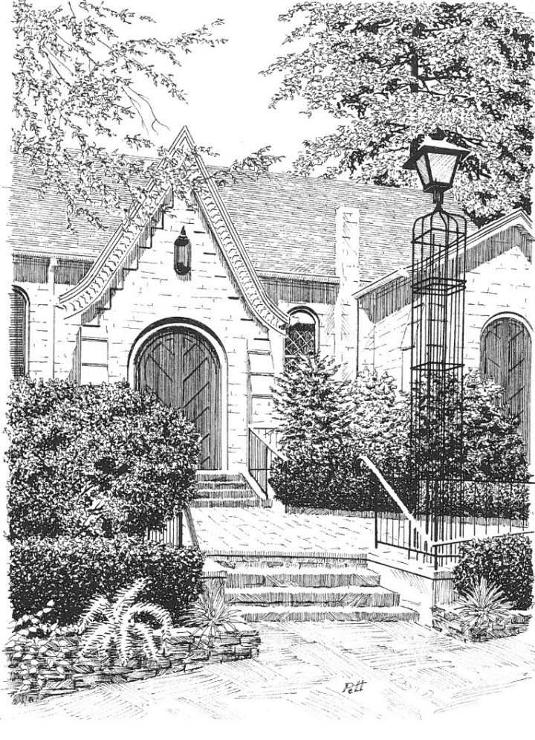

THE EPISCOPAL CHURCH OF ST. JOHN IN THE WILDERNESS

Est. 1836 | Flat Rock, North Carolina

Mission Statement

To know and love God as He is revealed to us in Jesus Christ, to bring others to His saving love, and to serve the world in his name.

Welcome and Reminders
We welcome you warmly to St. John in the Wilderness and invite you to share in our songs, prayers, and eucharistic feast. If you do not have a church family at this time, then we invite you to join in this fellowship of faith as we share life together as the Body of Christ. While we are broken and incomplete in many ways, we find God making us whole through this parish community. Fill out a card in your pew and put it in the offering plate or talk to an usher, greeter, or member of the clergy to learn more about St. John. It is wonderful to be with you today!

Reminders for Worship
- Masks are recommended but not required.

- If you find out that you have COVID-19 and that you might have brought it to this service, please call the church office and ask for the Rector.

- You will find hand sanitizer in the pews and with the ushers. Please use it after the Peace and before receiving Communion.

- Please participate in the service by singing and praying with us. At the time of the Peace, please take a few moments to leave your pew and greet others in the name of our Lord.

Holy Eucharist, Rite I

8:45 & 11:00am
During Lent, we dedicate ourselves to self-examination and repentance by prayer, fasting, self-denial, and by reading and meditating on God’s holy word (BCP, pg. 265).
To aid us in this work, we will not have prelude or postlude music for our services. We invite you to a time of quiet prayer before we begin and after we end worship.
If, however, we sacrifice hospitality and warmth on the altar of our devotions, then we miss the invitation to a holy Lent indeed.
The service starts in silence, with all standing as the procession begins.
The Great Litany BCP p. 148/Hymnal No. 67
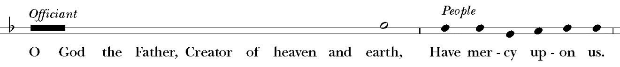
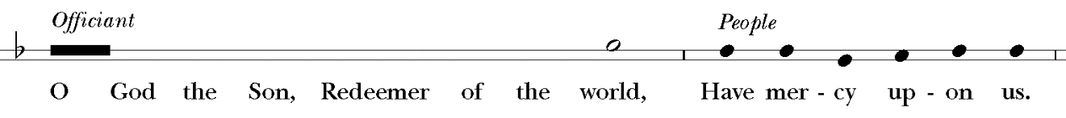
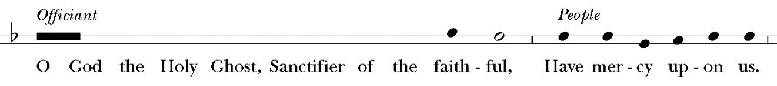
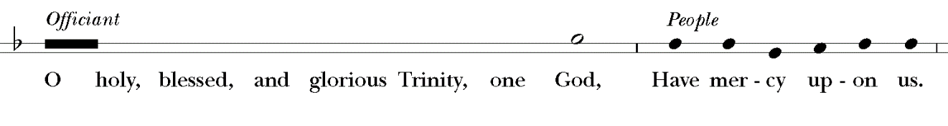
Remember not, Lord Christ, our offenses, nor the offenses of our forefathers; neither reward us according to our sins. Spare us, good Lord, spare thy people, whom thou hast redeemed with thy most precious blood, and by thy mercy preserve us, for ever.
From all evil and wickedness; from sin; from the crafts and assaults of the devil; and from everlasting damnation,
From all blindness of heart; from pride, vainglory, and hypocrisy; from envy, hatred, and malice; and from all want of charity,
From all inordinate and sinful affections; and from all the deceits of the world, the flesh, and the devil,
From all false doctrine, heresy, and schism; from hardness of heart, and contempt of thy Word and commandment,
From lightning and tempest; from earthquake, fire, and flood; from plague, pestilence, and famine,
From all oppression, conspiracy, and rebellion; from violence, battle, and murder; and from dying suddenly and unprepared,
By the mystery of thy holy Incarnation; by thy holy Nativity and submission to the Law; by thy Baptism, Fasting, and Temptation,
By thine Agony and Bloody Sweat; by thy Cross and Passion; by thy precious Death and Burial; by thy glorious Resurrection and Ascension; and by the Coming of the Holy Ghost,
In all time of our tribulation; in all time of our prosperity; in the hour of death, and in the day of judgment,
We sinners do beseech thee to hear us, O Lord God; and that it may please thee to rule and govern thy holy Church Universal in the right way,
That it may please thee to illumine all bishops, priests, and deacons, with true knowledge and understanding of thy Word; and that both by their preaching and living, they may set it forth, and show it accordingly,
That it may please thee to bless and keep all thy people,
That it may please thee to send forth laborers into thy harvest, and to draw all mankind into thy kingdom,
That it may please thee to give to all people increase of grace to hear and receive thy Word, and to bring forth the fruits of the Spirit,
That it may please thee to bring into the way of truth all such as have erred, and are deceived,
That it may please thee to give us a heart to love and fear thee, and diligently to live after thy commandments,
That it may please thee so to rule the hearts of thy servants, the President of the United States (or of this nation), and all others in authority, that they may do justice, and love mercy, and walk in the ways of truth,
That it may please thee to make wars to cease in all the world; to give to all nations unity, peace, and concord; and to bestow freedom upon all peoples,
That it may please thee to show thy pity upon all prisoners and captives, the homeless and the hungry, and all who are desolate and oppressed,
That it may please thee to give and preserve to our use the bountiful fruits of the earth, so that in due time all may enjoy them,
That it may please thee to inspire us, in our several callings, to do the work which thou givest us to do with singleness of heart as thy servants, and for the common good,
That it may please thee to preserve all who are in danger by reason of their labor or their travel,
That it may please thee to preserve, and provide for, all women in childbirth, young children and orphans, the widowed, and all whose homes are broken or torn by strife,
That it may please thee to visit the lonely; to strengthen all who suffer in mind, body, and spirit; and to comfort with thy presence those who are failing and infirm,
That it may please thee to support, help, and comfort all who are in danger, necessity, and tribulation,
That it may please thee to have mercy upon all mankind,
That it may please thee to give us true repentance; to forgive us all our sins, negligences, and ignorances; and to endue us with the grace of thy Holy Spirit to amend our lives according to thy holy Word,
That it may please thee to forgive our enemies, persecutors, and slanderers, and to turn their hearts,
That it may please thee to strengthen such as do stand; to comfort and help the weak-hearted; to raise up those who fall; and finally to beat down Satan under our feet,
That it may please thee to grant to all the faithful departed eternal life and peace,
That it may please thee to grant that, in the fellowship of the Blessed Vigrin Mary, St. John, and all the saints, we may attain to thy heavenly kingdom,
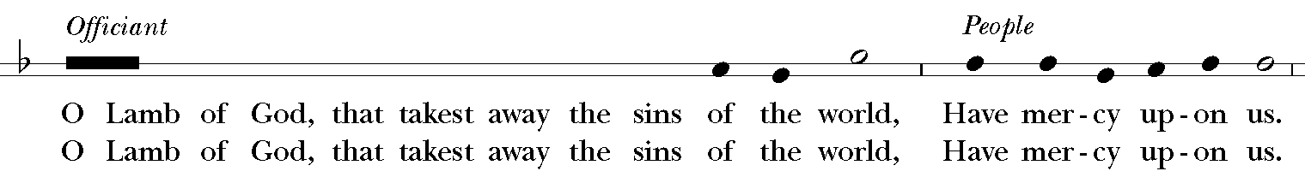
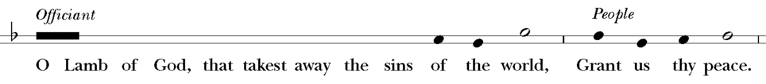
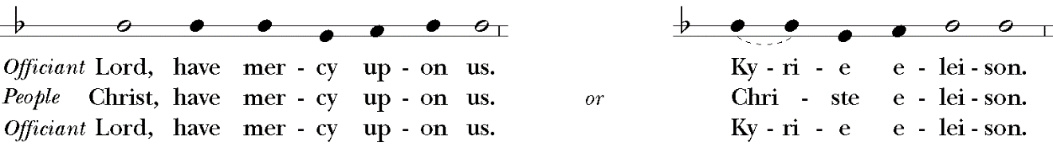
THE WORD OF GOD
Acclamation & Response
Celebrant Bless the Lord who forgiveth all our sins.
People His mercy endureth for ever.
The Celebrant says
Almighty God, unto whom all hearts are open, all desires known, and from whom no secrets are hid: Cleanse the thoughts of our hearts by the inspiration of thy Holy Spirit, that we may perfectly love thee, and worthily magnify thy holy Name; through Christ our Lord. Amen.
Hear what our Lord Jesus Christ saith: Thou shalt love the Lord thy God with all thy heart, and with all thy soul, and with all thy mind. This is the first and great commandment. And the second is like unto it: Thou shalt love thy neighbor as thyself. On these two commandments hang all the Law and the Prophets.
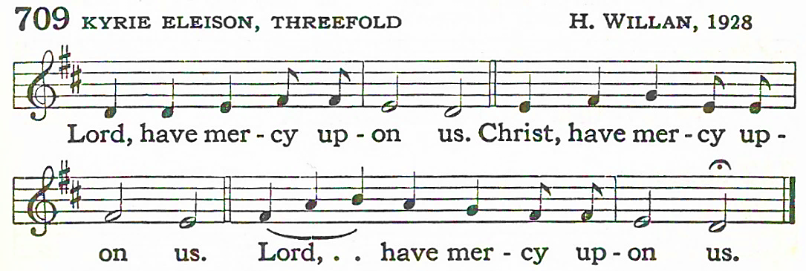
The Celebrant says to the people
The Lord be with you.
People And with thy spirit.
Celebrant Let us pray.

The Collect of the Day
Almighty God, whose blessed Son was led by the Spirit to be tempted of Satan: Make speed to help thy servants who are assaulted by manifold temptations; and, as thou knowest their several infirmities, let each one find thee mighty to save; through Jesus Christ thy Son our Lord, who liveth and reigneth with thee and the Holy Spirit, one God, now and for ever. Amen.
First Lesson: Genesis 2:15-17, 3:1-7
The Lord God took the man and put him in the garden of Eden to till it and keep it. And the Lord God commanded the man, “You may freely eat of every tree of the garden; but of the tree of the knowledge of good and evil you shall not eat, for in the day that you eat of it you shall die.”
Now the serpent was more crafty than any other wild animal that the Lord God had made. He said to the woman, “Did God say, ‘You shall not eat from any tree in the garden’?” The woman said to the serpent, “We may eat of the fruit of the trees in the garden; but God said, ‘You shall not eat of the fruit of the tree that is in the middle of the garden, nor shall you touch it, or you shall die.’“ But the serpent said to the woman, “You will not die; for God knows that when you eat of it your eyes will be opened, and you will be like God, knowing good and evil.” So when the woman saw that the tree was good for food, and that it was a delight to the eyes, and that the tree was to be desired to make one wise, she took of its fruit and ate; and she also gave some to her husband, who was with her, and he ate. Then the eyes of both were opened, and they knew that they were naked; and they sewed fig leaves together and made loincloths for themselves.
The Word of the Lord.
People Thanks be to God.
Psalm 32 Beati quorum
The Psalm is read responsively by whole verse.
1 Happy are they whose transgressions are forgiven, *
and whose sin is put away!
2 Happy are they to whom the Lord imputes no guilt, *
and in whose spirit there is no guile!
3 While I held my tongue, my bones withered away, *
because of my groaning all day long.
4 For your hand was heavy upon me day and night; *
my moisture was dried up as in the heat of summer.
5 Then I acknowledged my sin to you, *
and did not conceal my guilt.
6 I said," I will confess my transgressions to the Lord." *
Then you forgave me the guilt of my sin.
7 Therefore all the faithful will make their prayers to you in time of trouble; *
when the great waters overflow, they shall not reach them.
8 You are my hiding-place;
you preserve me from trouble; *
you surround me with shouts of deliverance.
9 "I will instruct you and teach you in the way that you should go; *
I will guide you with my eye.
10 Do not be like horse or mule, which have no understanding; *
who must be fitted with bit and bridle,
or else they will not stay near you."
11 Great are the tribulations of the wicked; *
but mercy embraces those who trust in the Lord.
12 Be glad, you righteous, and rejoice in the Lord; *
shout for joy, all who are true of heart.
Second Lesson: Romans 5:12-19
As sin came into the world through one man, and death came through sin, and so death spread to all because all have sinned-- sin was indeed in the world before the law, but sin is not reckoned when there is no law. Yet death exercised dominion from Adam to Moses, even over those whose sins were not like the transgression of Adam, who is a type of the one who was to come.
But the free gift is not like the trespass. For if the many died through the one man's trespass, much more surely have the grace of God and the free gift in the grace of the one man, Jesus Christ, abounded for the many. And the free gift is not like the effect of the one man's sin. For the judgment following one trespass brought condemnation, but the free gift following many trespasses brings justification. If, because of the one man's trespass, death exercised dominion through that one, much more surely will those who receive the abundance of grace and the free gift of righteousness exercise dominion in life through the one man, Jesus Christ.
Therefore just as one man's trespass led to condemnation for all, so one man's act of righteousness leads to justification and life for all. For just as by the one man's disobedience the many were made sinners, so by the one man's obedience the many will be made righteous.
The Word of the Lord.
People Thanks be to God.
As the music begins, all stand for the gradual hymn and reorient themselves to the Gospel of our Lord as it is processed into the congregation.
GRADUAL HYMN: No. 147 Now let us all with one accord Bourbon
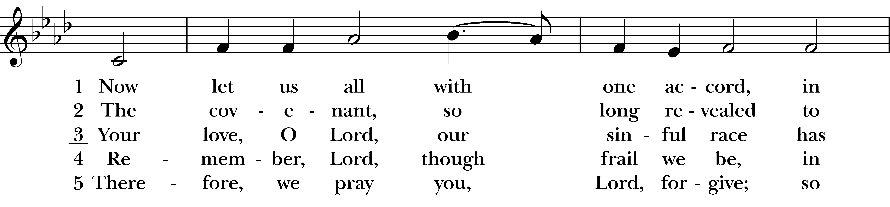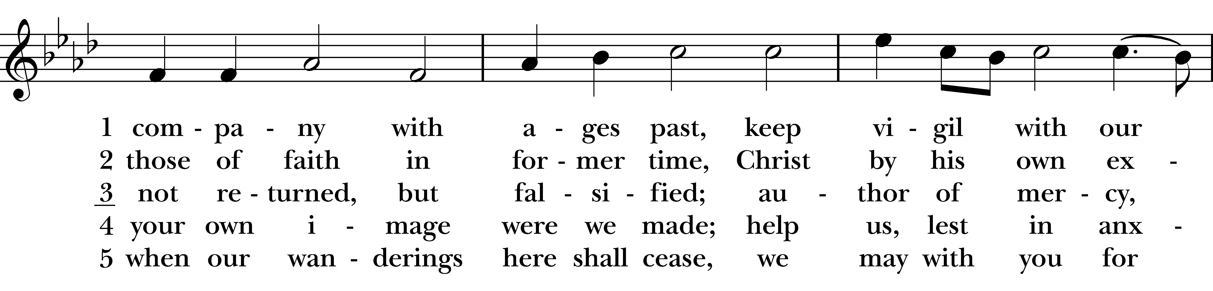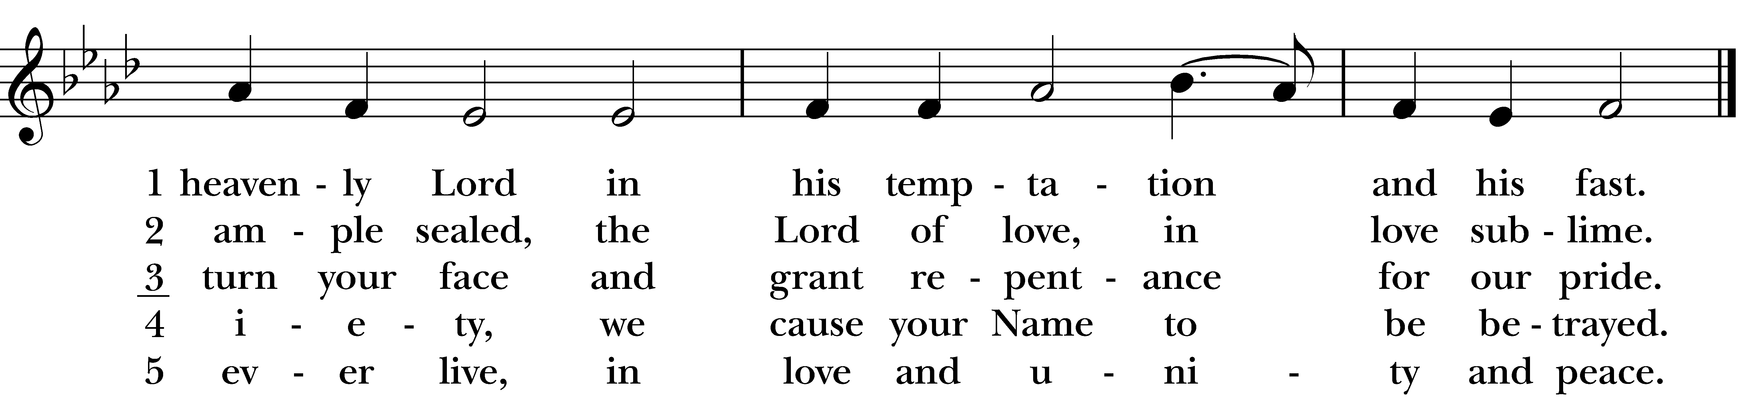
All remain standing as the Deacon or a Priest reads the Gospel, first saying
The Holy Gospel of our Lord Jesus Christ according to Matthew.
People Glory be to thee, Lord Christ.
The Gospel: Matthew 4:1-11
Jesus was led up by the Spirit into the wilderness to be tempted by the devil. He fasted forty days and forty nights, and afterwards he was famished. The tempter came and said to him, “If you are the Son of God, command these stones to become loaves of bread.” But he answered, “It is written,
‘One does not live by bread alone,
but by every word that comes from the mouth of God.’”
Then the devil took him to the holy city and placed him on the pinnacle of the temple, saying to him, “If you are the Son of God, throw yourself down; for it is written,
‘He will command his angels concerning you,’
and ‘On their hands they will bear you up,
so that you will not dash your foot against a stone.’”
Jesus said to him, “Again it is written, ‘Do not put the Lord your God to the test.’”
Again, the devil took him to a very high mountain and showed him all the kingdoms of the world and their splendor; and he said to him, “All these I will give you, if you will fall down and worship me.” Jesus said to him, “Away with you, Satan! for it is written,
‘Worship the Lord your God,
and serve only him.’”
Then the devil left him, and suddenly angels came and waited on him.
The Gospel of the Lord.
People Praise be to thee, Lord Christ.
The Sermon Fr. Ian Williams
After the sermon, there is a brief moment of silence. When the Celebrant rises, the congregation stands.
The Nicene Creed
We believe in one God,
the Father, the Almighty,
maker of heaven and earth,
of all that is, seen and unseen.
We believe in one Lord, Jesus Christ,
the only Son of God,
eternally begotten of the Father,
God from God, Light from Light,
true God from true God,
begotten, not made,
of one Being with the Father.
Through him all things were made.
For us and for our salvation he came down from heaven:
by the power of the Holy Spirit he became incarnate from the Virgin Mary,
and was made man.
For our sake he was crucified under Pontius Pilate;
he suffered death and was buried.
On the third day he rose again in accordance with the Scriptures;
he ascended into heaven and is seated at the right hand of the Father.
He will come again in glory to judge the living and the dead,
and his kingdom will have no end.
We believe in the Holy Spirit, the Lord, the giver of life,
who proceeds from the Father and the Son.
With the Father and the Son he is worshiped and glorified.
He has spoken through the Prophets.
We believe in one holy catholic and apostolic Church.
We acknowledge one baptism for the forgiveness of sins.
We look for the resurrection of the dead,
and the life of the world to come. Amen.
Welcome & Announcements Fr. Josh Stephens
The Exchange of Peace
All stand. The Celebrant says to the people
The peace of the Lord be always with you.
People And with thy spirit.
Then the Ministers and People may greet one another in the name of the Lord. The Celebrant then shares an offertory sentence.

THE HOLY COMMUNION
The Offertory
The ushers pass the offering plates and present the gifts of the congregation at the Lord’s table.
OFFERTORY MUSIC: 8:45 Variations on “Jesu meine Zuversicht” Johann Walther
11:00 Create in Me a Clean Heart, O God Carl Mueller
Text from Psalm 51:10-13
Create in me a clean heart, O God
and renew a right spirit within me.
Cast me not away from thy presence;
and take not thy Holy Spirit from me.
Restore unto me the joy of salvation,
and uphold me with thy free spirit.
Then will I teach transgressors thy ways;
and sinners shall be converted unto thee.
OFFERTORY RESPONSE: Praise God from whom all blessings flow Old 100th
Praise God, from whom all blessings flow; praise Him, all creatures here below;
Praise Him above ye heavenly host; praise Father, Son and Holy Ghost. Amen.

The Great Thanksgiving Eucharistic Prayer I
The people remain standing. The Celebrant faces them and says
The Lord be with you.
People And with thy spirit.
Celebrant Lift up your hearts.
People We lift them up unto the Lord.
Celebrant Let us give thanks unto our Lord God.
People It is meet and right so to do.
Then, facing the Holy Table, the Celebrant proceeds
It is very meet, right, and our bounden duty, that we should at all times, and in all places, give thanks unto thee, O Lord, holy Father, almighty, everlasting God.
Here a Proper Preface is sung or said on all Sundays, and on other occasions as appointed.
Therefore with Angels and Archangels, and with all the company of heaven, we laud and magnify thy glorious Name; evermore praising thee, and singing,
SANCTUS Hymnal S-114
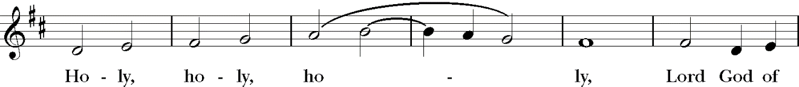
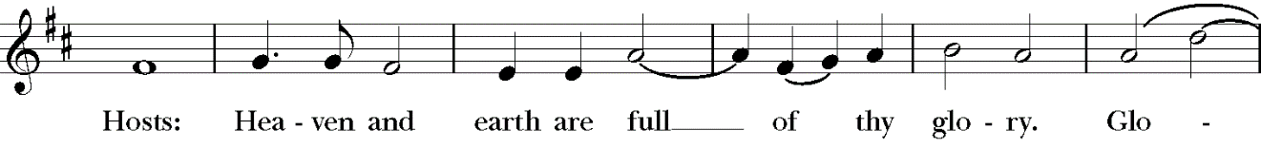
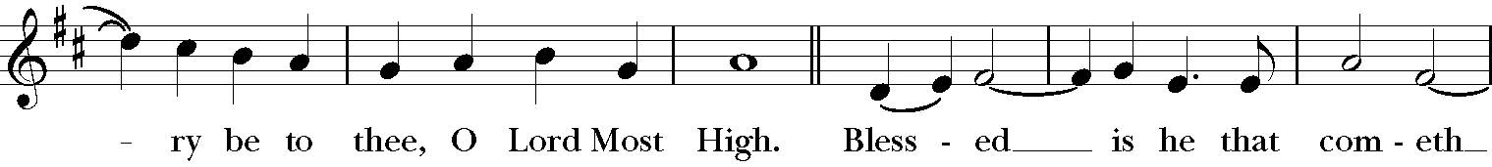
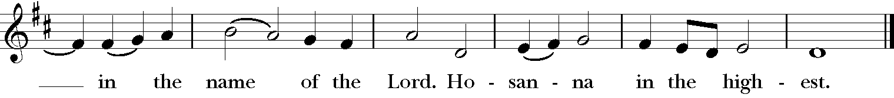
The people stand or kneel.

Then the Celebrant continues
All glory be to thee, Almighty God, our heavenly Father, for that thou, of thy tender mercy, didst give thine only Son Jesus Christ to suffer death upon the cross for our redemption; who made there, by his one oblation of himself once offered, a full, perfect, and sufficient sacrifice, oblation, and satisfaction, for the sins of the whole world; and did institute, and in his holy Gospel command us to continue, a perpetual memory of that his precious death and sacrifice, until his coming again.
At the following words concerning the bread, the Celebrant is to hold it, or to lay a hand upon it; and at the words concerning the cup, to hold or place a hand upon the cup and any other vessel containing wine to be consecrated.
For in the night in which he was betrayed, he took bread; and when he had given thanks, he brake it, and gave it to his disciples, saying, “Take, eat, this is my Body, which is given for you. Do this in remembrance of me.”
Likewise, after supper, he took the cup; and when he had given thanks, he gave it to them, saying, “Drink ye all of this; for this is my Blood of the New Testament, which is shed for you, and for many, for the remission of sins. Do this, as oft as ye shall drink it, in remembrance of me.”
Wherefore, O Lord and heavenly Father, according to the institution of thy dearly beloved Son our Savior Jesus Christ, we, thy humble servants, do celebrate and make here before thy divine Majesty, with these thy holy gifts, which we now offer unto thee, the memorial thy Son hath commanded us to make; having in remembrance his blessed passion and precious death, his mighty resurrection and glorious ascension; rendering unto thee most hearty thanks for the innumerable benefits procured unto us by the same.
And we most humbly beseech thee, O merciful Father, to hear us; and, of thy almighty goodness, vouchsafe to bless and sanctify, with thy Word and Holy Spirit, these thy gifts and creatures of bread and wine; that we, receiving them according to thy Son our Savior Jesus Christ’s holy institution, in remembrance of his death and passion, may be partakers of his most blessed Body and Blood.
And we earnestly desire thy fatherly goodness mercifully to accept this our sacrifice of praise and thanksgiving; most humbly beseeching thee to grant that, by the merits and death of thy Son Jesus Christ, and through faith in his blood, we, and all thy whole Church, may obtain remission of our sins, and all other benefits of his passion.
And here we offer and present unto thee, O Lord, our selves, our souls and bodies, to be a reasonable, holy, and living sacrifice unto thee; humbly beseeching thee that we, and all others who shall be partakers of this Holy Communion, may worthily receive the most precious Body and Blood of thy Son Jesus Christ, be filled with thy grace and heavenly benediction, and made one body with him, that he may dwell in us, and we in him.
And although we are unworthy, through our manifold sins, to offer unto thee any sacrifice, yet we beseech thee to accept this our bounden duty and service, not weighing our merits, but pardoning our offenses, through Jesus Christ our Lord; By whom, and with whom, in the unity of the Holy Ghost, all honor and glory be unto thee, O Father Almighty, world without end. AMEN.
And now, as our Savior Christ has taught us, we are bold to say,
People Our Father, who art in heaven,
hallowed be thy Name,
thy kingdom come, thy will be done
on earth as it is in heaven.
Give us this day our daily bread.
And forgive us our trespasses,
as we forgive those
who trespass against us.
And lead us not into temptation,
but deliver us from evil.
For thine is the kingdom,
and the power, and the glory, for ever and ever. Amen.
The Breaking of the Bread
The Celebrant breaks the consecrated Bread. A period of silence is kept.
Celebrant Christ our Passover is sacrificed for us;
People Therefore let us keep the feast.
The Agnus Dei is said at 8:45 and sung at 11:00. Music for the sung version is on the following page.
O Lamb of God, that takest away the sins of the world,
have mercy upon us.
O Lamb of God, that takest away the sins of the world,
have mercy upon us.
O Lamb of God, that takest away the sins of the world,
grant us thy peace.

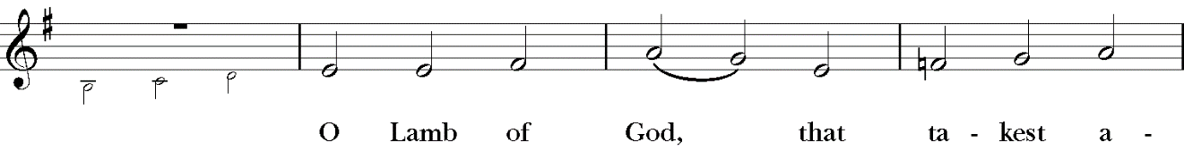
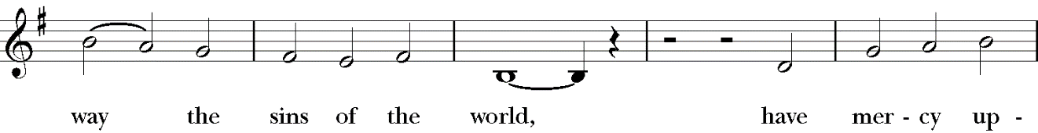
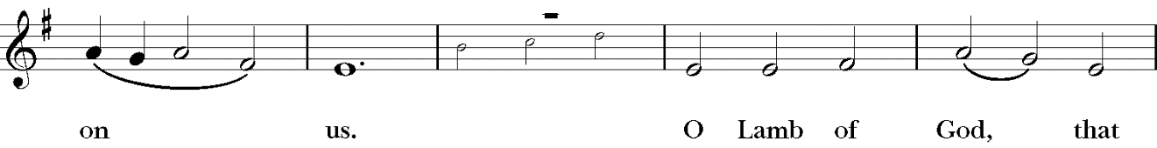
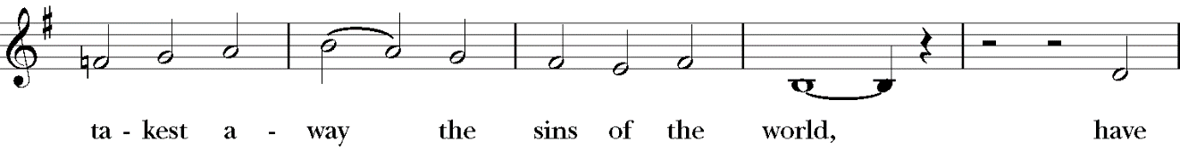
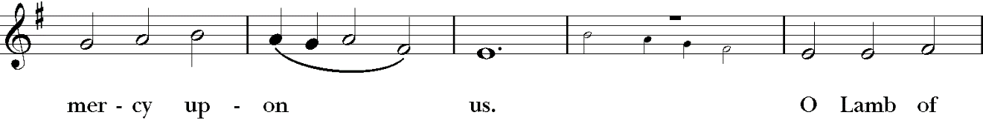
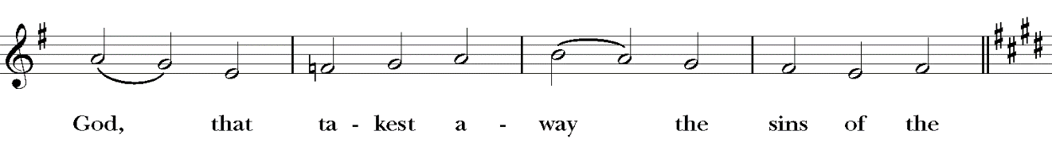
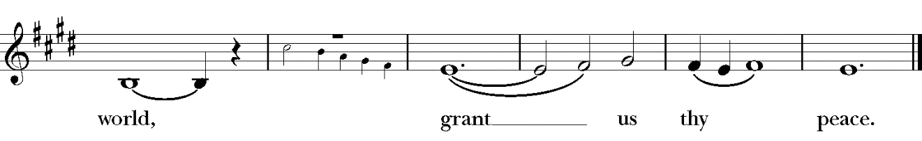
Celebrant and People
We do not presume to come to this thy Table, O merciful Lord, trusting in our own righteousness, but in thy manifold and great mercies. We are not worthy so much as to gather up the crumbs under thy Table. But thou art the same Lord whose property is always to have mercy. Grant us therefore, gracious Lord, so to eat the flesh of thy dear Son Jesus Christ, and to drink his blood, that we may evermore dwell in him, and he in us. Amen.
Facing the people, the Celebrant says the following Invitation
The Gifts of God for the People of God.
and may add
Take them in remembrance that Christ died for you, and feed on him in your hearts by faith, with thanksgiving.
The ushers immediately begin releasing the congregation to share in the Eucharistic feast. All are invited to come forward and kneel as you are able. If you would rather not receive Communion, you are invited to still come to the altar rail and cross your arms over your chest to indicate for the priest to bless you.
If you are receiving Communion, please do one of three things when you kneel: 1.) Most traditionally, place one hand in the palm of the other and receive the Body of Christ which you consume immediately. When the chalice comes around, guide it to your lips and drink directly from the chalice. 2.) To receive Communion in one kind (the bread alone), simply receive the bread as described above and when the chalice comes around, cross both arms over your chest. 3.) If you would like to practice intinction, upon arriving at the altar rail, place one arm diagonally across your chest until the priest notices your preference, then put one hand in the palm of the other to receive Communion. The priest will intinct for you and then place the Body and Blood of Christ in the palm of your hands. A gluten-free option is available upon request.
COMMUNION HYMN: No. 313 Let thy Blood in mercy poured Jesu, mein Zuversicht
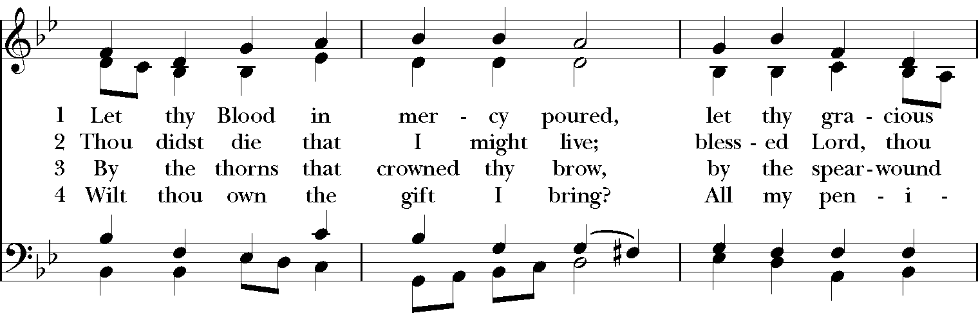
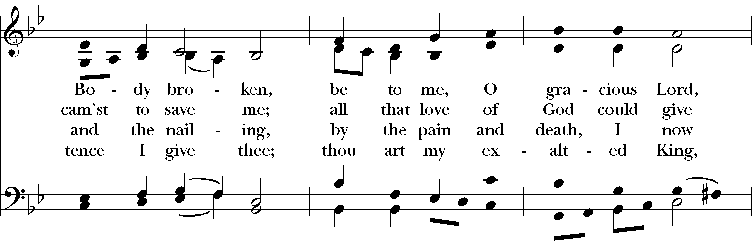
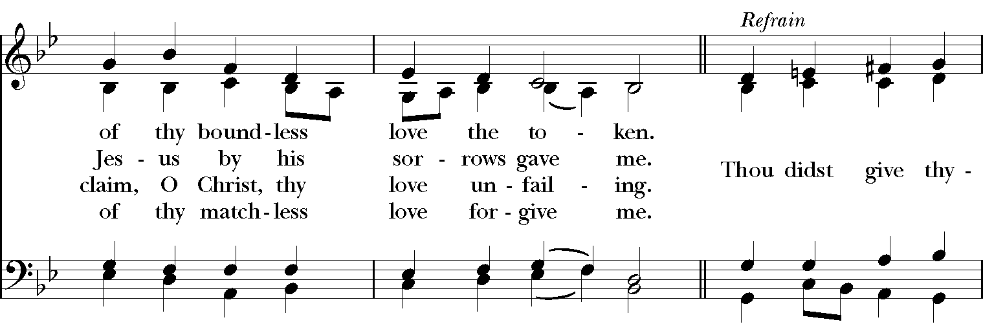
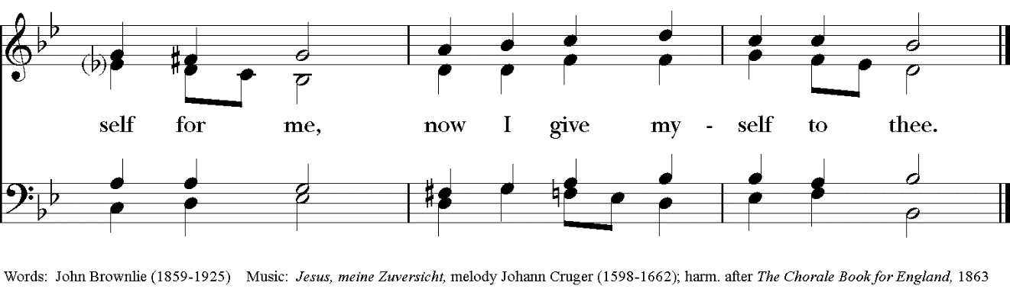

Sending Out of Eucharistic Visitors
Celebrant With whom will you share this communion?
Eucharistic Visitors respond with the names of those to whom they will go.
Celebrant In the name of this congregation, we send you forth bearing these holy gifts that those to whom you go may share with us in the communion of Christ’s body and blood.
People We who are many are one body, because we share one bread and one cup.
After Communion, the Celebrant says
Let us pray.
The people stand or kneel for the Post-Communion Prayer.
Celebrant and People
Almighty and everliving God, we most heartily thank thee for that thou dost feed us, in these holy mysteries, with the spiritual food of the most precious Body and Blood of thy Son our Savior Jesus Christ; and dost assure us thereby of thy favor and goodness towards us; and that we are very members incorporate in the mystical body of thy Son, the blessed company of all faithful people; and are also heirs, through hope, of thy everlasting kingdom. And we humbly beseech thee, O heavenly Father, so to assist us with thy grace, that we may continue in that holy fellowship, and do all such good works as thou hast prepared for us to walk in; through Jesus Christ our Lord, to whom with thee and the Holy Ghost, be all honor and glory, world without end. Amen.
The Deacon or, in the absence of a deacon, the Presider says
Bow down before the Lord.
The people kneel, and the Deacon says
Grant, Almighty God, that your people may recognize their weakness and put their whole trust in your strength, so that they may rejoice for ever in the protection of your loving providence; through Christ our Lord. Amen.
DISMISSAL HYMN: No. 446 Praise to the Holiest in the height Newman
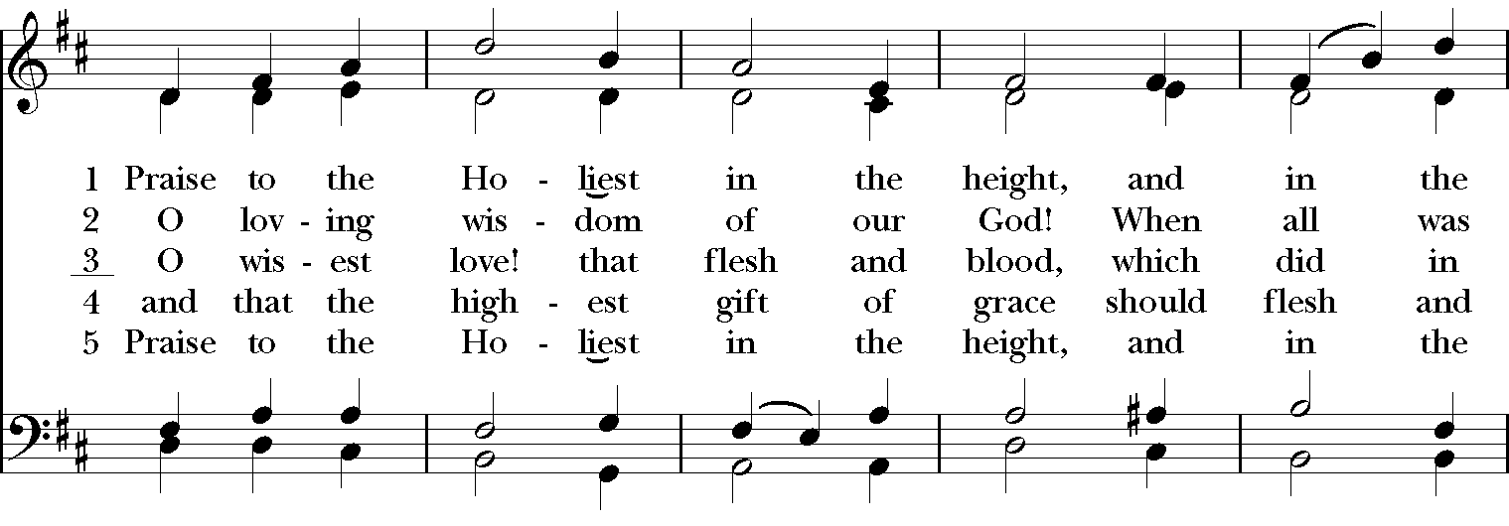
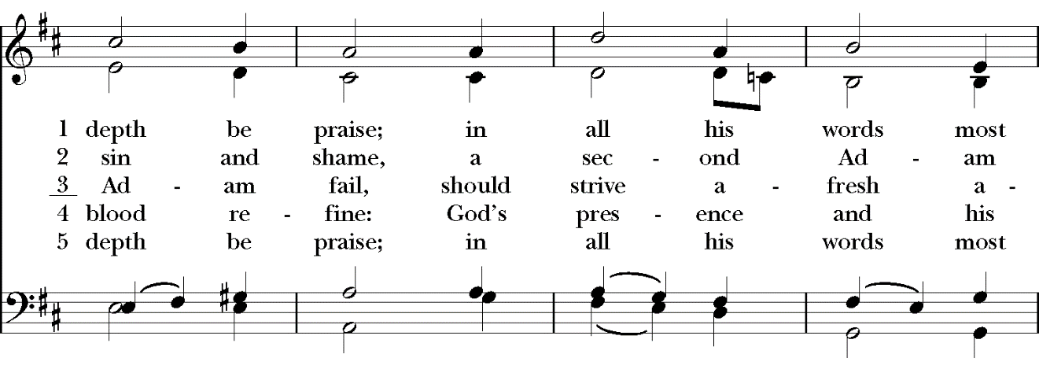
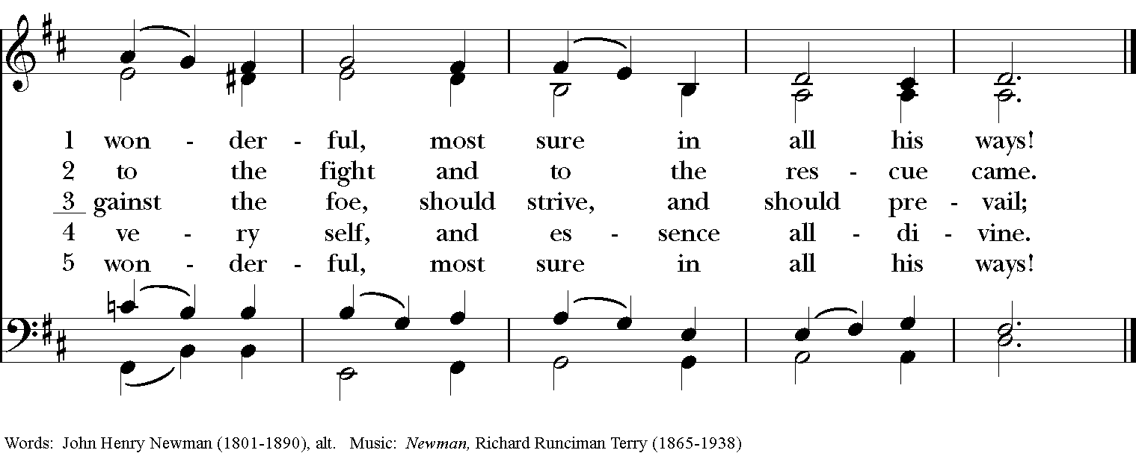
The Dismissal
The Deacon, or the Celebrant, may dismiss the people with these words
Deacon Go in peace to love and serve the Lord.
People Thanks be to God.
During Lent, we invite those who would like to remain in the church for quiet prayer to do so. Please see the note at the beginning of the service for more information.

The Prayers of the People is that part of our liturgy which offers intercessions and thanksgivings to God. Worshippers, wherever they are in the church, are encouraged to offer aloud or silently their own such prayers during the appropriate part of the Prayers of the People. As we pray, please remember those who are ill or with other needs: Joanne Adams, Dottie Dalzell, Tom and Anna Joiner, Gene Banks, Belle and Dana Welk, Jim Chestnut, Patsy Boehmer, Jan Knapp, Emily Everhope, Creighton and Louise McShane, John Flowers, Mary McCarty, Martha Stevenson, Gail Sanders, Christopher Carlson, Marge Smith, Anna Kinsey, Ashley Schimmel, and Hal Reid.
Lay Eucharistic Visitors share the Body and Blood of Christ with those who receive care from our Homebound Ministry. We thank God for the ministry of Clint Adams, Margaret Barker, Katherine Gee, Michelle Geiser, Lori Griswold, E.R. Haire, Mary McCarty, Beth Miller, and Dick Zecher.
To our visitors: We welcome you with all our hearts! You are also invited to come forward at the time of Communion to receive a blessing or the Sacrament. All baptized Christians are encouraged to receive Communion, including infants and children. If you are not baptized, please come forward and kneel at the altar while crossing your arms over your chest to receive a special blessing, and we invite you to talk to the priest at any time about entering discernment for being baptized. Won’t you join with Christ and his Church on this journey of faith?
If you do not have a church home at this time, then we hope you will make St. John in the Wilderness your church family. We find that through sharing life together as the Body of Christ, we are made whole and renewed daily. Talk to an usher or member of the clergy about joining this parish, or you are welcome to simply fill out a card in your pew and put it in the offering plate. We welcome you!
February 26, 2023 March 5, 2023
8:45 11:00 8:45 11:00
Lay Readers Sandra Jeffery E.R. Haire, Jr. Judy Petersen Candace Lewis
Acolyte Margaret Barker Abby Stephens Laura Teel Susan Rex
Ushers Bob & Jodi Hilton Swing Debby Staton Bettie Orr
Sundeen Tom Savage George Grzenda Edgar Ham
Greeters Lynne Miller Patty Vint Lynne Miller Anna Kinsey
Judy Petersen Lois Karcher
Cart Driver Jill Owen Scott Bell Steve Hutcherson Jerry Beschta
Videography N/A Tom Griswold The Wiescholeks N/A
Altar Guild Carol Sims Susan Gibbs
Lynne Miller Lisa Wills
Gibson Sims (Brass)
Opening Gatekeeper BJ McKee & George Grzenda David Dethero
Closing Gatekeeper Jerry Holt Lynn Wiescholek
Flower Guild Carol Sims Galen Reuther

THE EPISCOPAL CHURCH OF ST. JOHN IN THE WILDERNESS
PO Box 185, 1905 Greenville Highway, Flat Rock, NC 28731
828-693-9783 | www.stjohnflatrock.org
In the case of a pastoral emergency, call the Parish Office and dial 5.

Worship Services: 8:45 & 11:00am | Office Hours: 9am-4pm M-F

Sunday School for Adults, Youth, and Children: 10:00am
Holy Eucharist & Healing Service: Wednesdays 10:30am in the Wilderness Room

The Rt. Rev. José McLoughlin, Bishop
The Rev. Josh Stephens, Rector: rector@stjohnflatrock.org
The Rev. Ian Williams, Curate: ian@stjohnflatrock.org
The Rev. Deacon Sandy Rex, Deacon: cwrexiii@rmimidwest.com
Dewitt Tipton, Organist/Director of Music: dewitt.tipton@furman.edu
Sarah Yeargin, Director of Parish Communication and Administration: officeadmin@stjohnflatrock.org
Stacy Knapp, Parish Financial Assistant: finance@stjohnflatrock.org
Kevin Hunt, Sexton: sexton@stjohnflatrock.org

VESTRY MEMBERS
Senior Warden: John Barker
Junior Warden: Will Rodriguez

2023
Elizabeth Christenbury
Lynn Wiescholek
Jennifer Shelton

2024
E.R. Haire, Jr.
Marisa Pharr
Kim Sanders
Clint Adams

2025
Laura Teel
Patrice German
Jerry Holt

PARISH OFFICERS
Margaret Barker, Clerk of the Vestry
Tom Griswold, Treasurer

STANDING COMMITTEES
Buildings and Grounds Committee:
By Laws, Canons & Insurance: Jim Olson
Christian Formation: Mary Anne Inglis
Communications & Publicity: Joey Popp
Finance: Susan MacDonald
Historic Churchyard Committee: Ken Jones
New Member Ministry: Brenda Hillyer, Judy Petersen
Outreach: Jennifer Shelton
Personnel: Margaret Barker
Stewardship: Clint Adams
OTHER COMMITTEES AND MINISTRIES
Acolytes: Lynn Savage
Altar Guild: Cathryn Harrell, Sally Hopper
Chefs of St. John: Jim Vint
Churchyard Trustees: Pete Petersen
Docents: E.R. Haire, Jr.
Endowment Trustees: Jim Spry
Episcopal Church Women: Linda Giltner
Flower Guild: Bay Chamberlain
Flower Memorials: Gaston Motes
Funeral Reception Ministry: Brenda Hillyer
Gatekeepers: Dick Zecher
Giving Garden: Kathryn Whitten, Carrie Byars
Golf Cart Ministry: Jill Owen
Greeters: Betsy Tibbs
Heritage, Archives & Gift Committee: John Barker
Homebound Ministry: The Revs. Patricia and Stephen Askew
Lay Readers: Mark Delk
Meal Ministry: Janelle Walker
Needle Work Ministry: Judy Petersen
Newsletter Editor: Sarah Yeargin
Sustainability: Lynn Wiescholek, Elizabeth Christenbury
Ushers: Clint Adams, Bettie Orr
Wedding Coordinator: Elaine Howe

